**Chapter 2**

**S-14**

1. Define the following terms:
   1. Object
   2. Class
2. Write a program to define a structure ‘Tender’ having data members tender-no., cost and company-name. Accept *&* display this data for two variable of this structure.
3. Explain memory allocation for objects with example.
4. Write a program to declare a class ‘Journal’ having data members as journal-name, price *&* no-of-pages. Accept this data for two objects *&* display the name of journal having greater price.
5. Write a program to define a class having data members principle, duration *&* rate-of-interest. Declare rate-of-interest as static member variable. Calculate the simple interest *&* display it for one object.
6. Explain the concept of friend function.
7. Write a program to declare a class ‘staff’ having data members as name *&* department. Accept this data for 10 staffs *&* display names of staff that are in cm department.

**S-15**

1. Write a program to create a class “student” having data member as name, roll no. and percentage to read and display details for 10 students.
2. Write a program to show use of passing object as a parameter to function showdata() for class “student” having data members as name and roll no and member function as getdata().

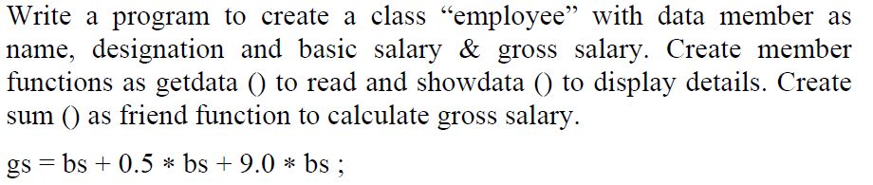

**S-16**

1. Write general form of member function definition out of class.
2. What is nesting of member function ? Give one example.
3. Explain with example object as member function argument.
4. List characteristics of static data members.
5. Compare structure and class.
6. Explain how memory is allocated for the objects of class in C++.
7. Write a program to declare class ‘complex’ with data members *x* and y. Write member function to read and print data members. Read *x* and y for two objects and add these two objects into third object using friend function.

**W-14**

1. Define class with it’s syntax.
2. Write any two rules to define friend function.
3. Define a structure with it’s syntax.
4. Write a program to define a class student having data members name and roll no. Accept and display data for one object.
5. Write a program to declare a class staff having data members as name and post. Accept and display data for five staff members. (Using array of object)
6. How many ways we can define member function in class ? Give it’s syntax.

**W15**

1. Write only errors if any from following code.

class abc

{ private : int *x* ;

public : void getdata ( ) ;

{ cout << “Enter data” ; cin << *x* ; }

} ;

1. Define friend function. Write syntax of declaring it.
2. Write a program to declare class ‘staff’ having data members as name and post. Accept this data for 5 staffs and display name of staff who are HOD.

**W16**

1. Write a program to declare a class mobile having data members as price and model number. Accept and display this data for ten objects.